**System Design Document**

**For**

**Dr. Brown Capstone Project Fall ‘23:**

**Portable Ultrasound Device for Coda-Wave Interferometry**

Team members:

Michael Kisellus, Matthew Baker, Layton Foxworthy, Kyle Fox, and Christopher Coppedge

| Version/Author | Date |
| --- | --- |
| v1 | 9/29/23 |
|  |  |
|  |  |
|  |  |

**TABLE OF CONTENT**

1 INTRODUCTION 3

1.1 Purpose and Scope 3

1.2 Project Executive Summary 3

1.2.1 System Overview 3

1.2.2 Design Constraints 3

1.2.3 Future Contingencies 3

1.3 Document Organization 3

1.4 Project References 4

1.5 Glossary 4

2 SYSTEM ARCHITECTURE 4

2.1 System Hardware Architecture 4

2.2 System Software Architecture 4

2.3 Internal Communications Architecture 4

3 HUMAN-MACHINE INTERFACE 4

3.1 Inputs 5

3.2 Outputs 5

4 DETAILED DESIGN 5

4.1 Hardware Detailed Design 6

4.2 Software Detailed Design 6

4.3 Internal Communications Detailed Design 7

5 EXTERNAL INTERFACES 7

5.1 Interface Architecture 7

5.2 Interface Detailed Design 8

6 SYSTEM INTEGRITY CONTROLS 8

**SYSTEM DESIGN DOCUMENT**

*Overview*

*The System Design Document describes the system requirements, operating environment, system and subsystem architecture, files and database design, input formats, output layouts, human-machine interfaces, detailed design, processing logic, and external interfaces.*

# **INTRODUCTION**

## **Purpose and Scope**

This project will produce a handheld ultrasound inspection device for inspecting a bridge/structural component for faults in the field. This handheld unit will have an independent power supply and will gather/store test data. All while being rugged enough to withstand field conditions such as shock from a fall, rain, and other environments a field tool will be exposed to.

## **Project Executive Summary**

This project will primarily consist of finding and integrating existing components into a cohesive system that matches our requirements.

### System Overview

The system will output ultrasonic signals to devices connected to the concrete being scanned, then detect the signals after they have traveled through the concrete. This will require a power sub-system, high voltage subsystem, and an input/storage subsystem. Figure 1 displays the overall system. Figure 2 displays the PUD system internal overall structure.

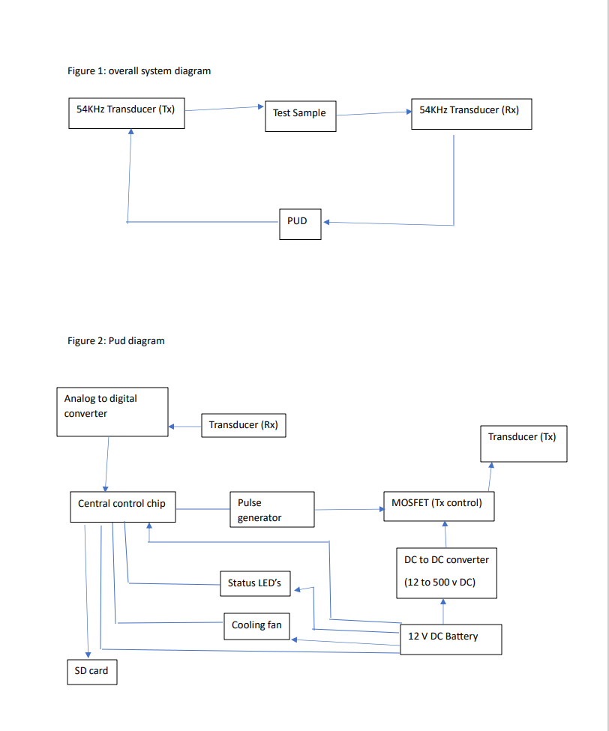



### Design Constraints

The design of our system will balance weight vs battery life, battery consumption vs cooling, and accuracy vs component price. Because one of the requirements of the system is to be portable we will be keeping the unit as light as possible. This comes in direct competition with battery life which also has its own requirement. Battery consumption and cooling are also going to have to be balanced to ensure the hardware, specifically the battery, stays within operating temperature. This would lead us to running the fans more but that increases battery consumption and decreases how long the system can be used in the field. Lastly, more accurate signal processing hardware costs more than its less accurate counterpart so our design uses components that are within budget and are also accurate enough for our application.

### Future Contingencies

The exact requirements of the system are dependent on the civil engineering laboratory, which serves as the primary stakeholder for the system. They will be the primary user of the system once it is operational so the requirements must match their expectations. Any changes to the system will depend on their wants and needs, and could be affected by potential miscommunications. Because the civil engineering lab already has some components of the final system, these are not going to change and are known to be good.

## **Document Organization**

The document adheres to the organizational structure and formatting prescribed by the course. Every section, heading, and subheading has been aligned with the template guidelines to maintain a consistent and professional appearance. By following the provided instructions and formatting guidelines, we aimed not only to meet the basic requirements but also to contribute to the overall uniformity of documentation between the multiple teams. This approach ensures that the professors and TAs can easily navigate the document.

## **Project References**

International Electrotechnical Commission (2013). Degrees of protection provided by enclosures (IP Code) (IEC 60529). Retrieved from https://website.iec.ch/publication/2452

This section provides a bibliography of key project references and deliverables that have been produced before this point.

## **Glossary**

**IP Rating [IPAB]** – Ingress Protection rating as codified under the IEC 60529 standard, where A is the device’s resistance to solid particle such as dust from zero (no protection) to 6 (most protection) and B is the device’s resistance to liquids from zero (no protection) to 9K (most protection). (International Electrotechnical Commission [IEC], 2013)

An IP55 rating means:

5-Ingress of dust is not entirely prevented, but it must not enter in sufficient quantity to interfere with the satisfactory operation of the equipment.

5-Water projected by a nozzle (6.3 mm) against enclosure from any direction shall have no harmful effects.

**PUD -** Portable ultrasound device

**LED**- Light emitting diode

Supply a glossary of all terms and abbreviations used in this document. If the glossary is several pages in length, it may be included as an appendix.

# **SYSTEM ARCHITECTURE**

This section outlines the overall system architecture, including both software and hardware architecture for the PUD system and subsystems.

## **System Hardware Architecture**

In this section, describe the overall system hardware and organization. Include a list of hardware components (with a brief description of each item) and diagrams showing the connectivity between the components. If appropriate, use subsections to address each subsystem.

**Cooling System**

The cooling system consists of multiple 80mm fans each connected to an integrated fan controller and temperature sensor to operate independently from one another to ensure that if one fan goes down the other(s) can still operate as well as making sure each area within the case gets the airflow that it requires. The fans will be placed on either end of an inner metal frame to drive the airflow over the components in the most efficient manner possible. The fan’s RPM rate will be tied to the system’s internal temperature via the following curve:

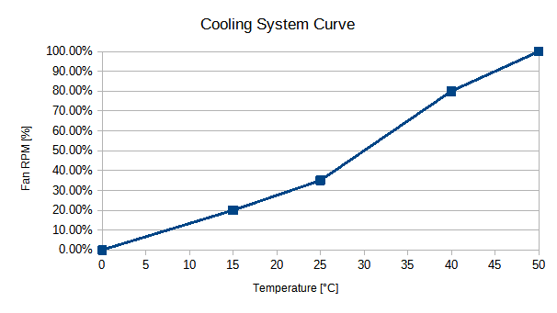

While the system’s design takes into account the possibility for the fans to run at maximum for the entire operating time, this thermal curve is in keeping with industry standards for keeping a computer system cooled while preventing too much current and power use from the internal power supply and thus preventing premature power drain.

Parts List:

Orion Fans OD8025-12HBIP55 Fan, 12VDC, 2.2 Watts at 0.18 Amps

EMC2101 integrated fan controller and thermocouple, 3V DC connected to central board.

5052-H32 Aluminum sheet metal with a thickness of 0.4mm, cut and folded to shape.

**Electrical System**

The PUD electrical system consists of a 12 v battery bank which is used to power various loads. Such as LED’s and cooling fans. There is a subsystem for charging the battery which is disconnected through an externally operable switch. The high voltage section consists of a 12v DC to 500v DC converter and a capacitor bank to maintain voltage. Electrical schematic shown in figure 3 below.

Parts list for electrical system(parts may be replaced with equivalent part):

* Capacitor:3300 µF 500 V Aluminum Electrolytic Capacitors Radial, Can - Screw Terminals 54mOhm @ 100Hz 20000 Hrs @ 85°C
* High Voltage Power Supply: Enclosed DC DC Converter 1 Output 0 ~ 500V 20mA 13V Input
* DC 12v 24v to 5v : DC 12v 24v to 5v Step Down Converter Regulator 5A 25W Power Adapter Reducer for Car Electronics Truck Vehicle Boat Solar System (Accept DC 8-40V Inputs)
* LED’s: LED COOL WHITE CLR 5MM RND T/H, White, Cool 9000K LED Indication - Discrete 3.2V Radial
* Battery charger: 5A & 10A 12V Smart Battery Charger with LCD Display for Lead Acid and Lithium (LiFePO4) Batteries
* Battery connection cables: 6 AWG (16mm²) 13 Inch Battery Interconnect Cable
* Battery: LiFePO4 12V 50Ah Lithium Iron Phosphate Battery
* Isolation switch: Battery Isolator Switch for Car Vehicle RV and Marine (On/Off)
* Wire: Ancor Marine Grade Primary Wire and Battery Cable
* Mosfet : N-Channel 500 V 14A (Tc) 30W (Tc) Through Hole TO-220FP
* Push button switch: Pushbutton Switch SPST-NC Standard Panel Mount, Front
* Resistor for capacitor bank: 47 kOhms ±5% 50W Wirewound Chassis Mount Resistor
* Transistor’s: Bipolar (BJT) Transistor NPN 36 V Through Hole TO-92-3
* Resistor for LED: 453 Ohms ±1% 0.25W, 1/4W Through Hole Resistor Axial Metal Film
* Bus for power distribution: 10 Position Wire to Board Terminal Block Horizontal with Board 0.197" (5.00mm) Through Hole
* Microcontroller RP2040
* Analog to Digital Converter with 100MSPS sampling rate and 100MHz bandwidth

Figure 3: PUD Electrical system

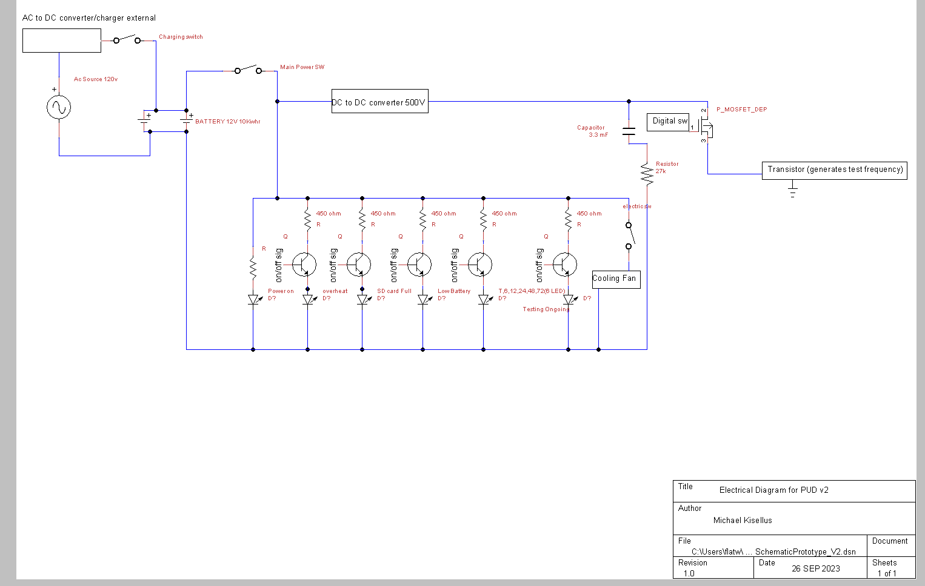

## **System Software Architecture**

In this section, describe the overall system software and organization. Include a list of software modules (this could include functions, subroutines, or classes), computer languages, and programming computer-aided software engineering tools (with a brief description of the function of each item). Use structured organization diagrams/object-oriented diagrams that show the various segmentation levels down to the lowest level. All features on the diagrams should have reference numbers and names. Include a narrative that expands on and enhances the understanding of the functional breakdown. If appropriate, use subsections to address each module.

## **Internal Communications Architecture**

The internal communications will consist of UART and SPI bus architecture. The UART will allow us to program the microcontroller. The SPI bus will be used by the microcontroller to interface between the ADC and the microcontroller. It will also allow us to use qSPI to interface with the SD card and store/move data very quickly between each separate hardware piece.

# **HUMAN-MACHINE INTERFACE**

The system will have input from the user to start the system and to determine how long the system should operate. This will be performed through physical buttons.As for outputs we will have LED indicators to display the system’s status to the operator. Additionally, a removable SD card will be able to be extracted from the system after it has gathered the desired data.

## **Inputs**

The system inputs will be physical buttons that send a voltage signal to our microcontroller. Because it is a simple 2-state button we will have the input to the microcontroller be a simple binary input. The buttons will correspond to modes that set the time the system will be in operation. This simplicity will make I/O controls simple and reliable.

The front panel physical button I/O options will be “Test System”, “6 Hour”, “12 Hour”, “24 Hour”, “48 Hour”, “72 Hour”, “Start Test” “Select Test Duration” and “Stop Test”.

Figure 4: Input panel for PUD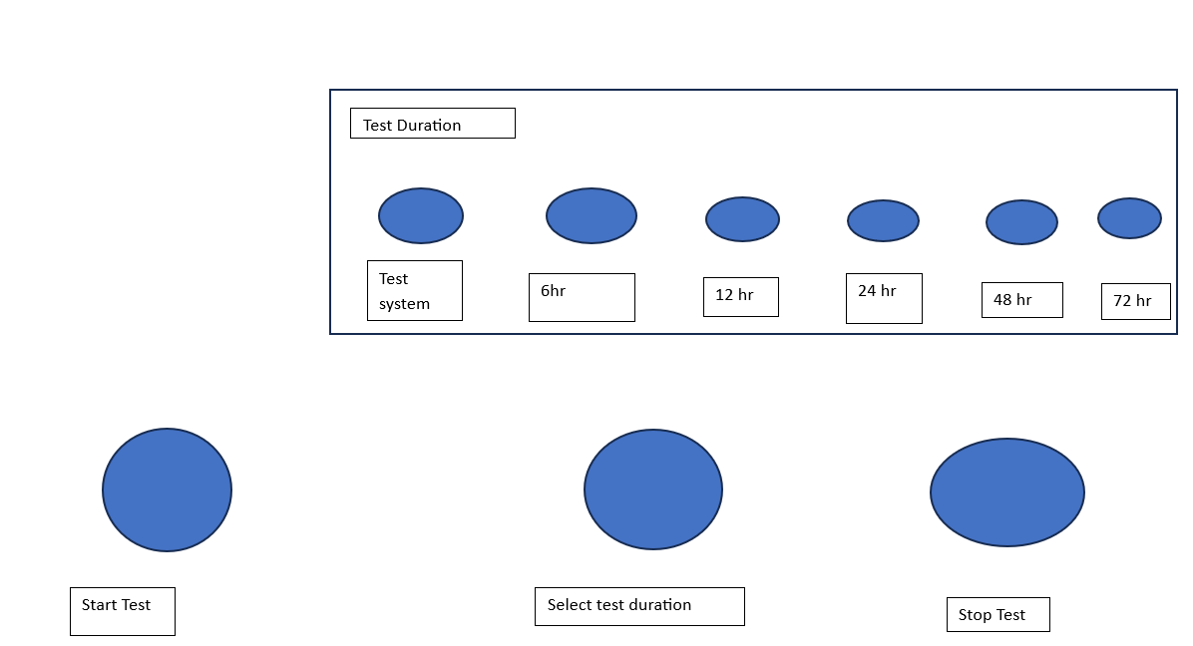

## **Outputs**

The outputs from our system come in two different forms. The data from the operation of the system, and the indicators that tell the operator the status of the system. The operator indicators will be presented on LEDs and the system’s output data from the concrete measurement will be stored on an SD card.

The operator’s indicators will be the representation of binary values in our microcontroller. The implementation of this will depend on the voltage the microcontroller is able to output so if it is not able to power the LED we may need a relay to switch the LED on. The indicators will include “Power Available”, “Low Battery”, “High Temperature”, “SD Card Full”, “Unit Charging Capacitor” and more if needed.

The data the system collects about the concrete will need to be converted to a digital signal and stored. This will then be written to an SD card for the operator to retrieve when the system is done with its operation. The retrieval will require the case to be opened. This helps protect the SD card against the weather. The output file one the SD card will mostly depend on the microcontroller and the file type used in the lab that processes the information.

Figure 5: Output panel for PUD 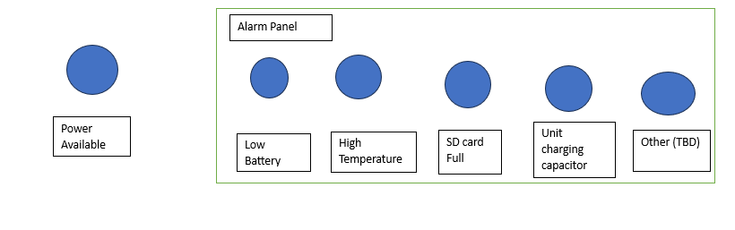

# **DETAILED DESIGN**

This section provides the information needed for a system development team to actually build and integrate the hardware components, code and integrate the software modules, and interconnect the hardware and software segments into a functional product. Additionally, this section addresses the detailed procedures for combining separate COTS packages into a single system. Every detailed requirement should map back to the FRD, and the mapping should be presented in an update to the RTM and include the RTM as an appendix to this design document.

## **Hardware Detailed Design**

The low level hardware design is split into 5 distinct parts. The microcontroller and control system, the output signal, the input signal, the environment control, and the power system.

**Environment Control and Cooling System**

The cooling system consists of pre-fabricated aluminum heat sinks attached to the various “hotspots'' of the system (CPUs, Capacitor bank, DC-DC convertor, etc.) via thermally-conductive and electrically neutral compounds such as grease or adhesive pads. These components are then attached via standoffs to a grounded aluminum frame to act as a heat spreader and to prevent electrical short circuits. This frame will consist of sheet aluminum bent into a U-shaped frame to house the actual internal components, with cutouts for wires and connectors, and a removable aluminum top panel fit by friction to enclose the “box” to better channel air across the components. The actual action of cooling the system is provided by Orion Fans OD8025-12HBIP55 fans placed into the casing so that one acts as an intake fan and the second as an exhaust fan. These fans are then connected to the aluminum box via plastic shrouds that will channel the air through the aluminum frame for maximum static pressure. Each fan in and of itself has an IP55 rating to aid in the overall elemental resistance of the unit. In the event that the temperature inside the case approaches the thermal cutoffs/damage zones for the components (i.e. 131 degrees Fahrenheit for the DC-DC converter), the fans will be spun up to maximum RPM to prevent thermal throttling or damage to the components and will reduce RPMs according to a programmed hysteresis curve in the system’s firmware. The source of the temperature information will from the EMC2101 integrated fan controller breakout boards in the main body each of which will be in a different position within the case (e.g.beside the DC-DC converter) to ensure that each fan can operate independently as well as run at a speed that will aid in cooling local components..Additional fans and controllers may be added to provide airflow and cooling to other components inside the case (i.e. battery, capacitors, etc.). Each fan draws 2.2 watts at 0.18 amps, and each board requires a 3-3.6V supply voltage to operate effectively which it can receive from the Raspberry Pi Pico at the heart of the system. The fan controller boards connect to the fans via a standard 4-pin fan connector and to the Pico via a V_in, GND, and 3V pinout. The aluminum selected for the frame is 5052-H32 sheet aluminum at a thickness of 0.4mm which has strong corrosion resistance and is used in marine environments.

**Electrical and Power System**

The electrical system consists of 2 main buses. Note: electrical bus bars are used to distribute power. A 12 V DC bus and a 500 V DC bus are used.

The 12 V DC bus consists of 2 loops. The first loop is used to recharge the LiFePO4 12V 50Ah Lithium Iron Phosphate Battery. The battery is connected using 6 AWG (16mm²) 13 Inch Battery Interconnect Cable to the exterior of the casing and is accessible without opening the case. A Battery Isolator Switch for Car Vehicle RV and Marine (On/Off) is used to isolate the battery charging loop when not in use.The battery charger used is a 5A & 10A 12V Smart Battery Charger with LCD Display for Lead Acid and Lithium (LiFePO4) Batteries. The second loop connects the battery to the 12 V DC load bus which powers the various loads of the system.The battery has a switch to open this loop and turn off the system. The battery connects to the 10 Position Wire to Board Terminal Block Horizontal with Board. This is used to connect the various 12 v loads. Including the LED indicating lights which require a 453 Ohms ±1% 0.25W, 1/4W Through Hole Resistor Axial Metal Film to reduce voltage and current to 3.3v and 20mA for the LED to operate. The LED uses a Transistor’s: Bipolar (BJT) Transistor NPN 36 V Through Hole TO-92-3 to receive signals from the controlling chip to turn on or off. The cooling fan receives power from this bus. The controlling chip receives its power from this bus. The DC 12v 24v to 5v Step Down Converter Regulator 5A 25W Power Adapter Reducer for Car Electronics Truck Vehicle Boat Solar System (Accept DC 8-40V Inputs) receives power from this bus and its output is used as control power on the Enclosed DC DC Converter 1 Output 0 ~ 500V 20mA 13V Input. The 12V DCto 500V DC converter receives its main power from this bus and sends power to the 500V bus.

The 500V DC bus starts at the 12V DC to 500V DC converter and is used to charge a 3300 µF 500 V Aluminum Electrolytic Capacitor which acts as a voltage regulator for normal operation.Ancor Marine Grade Primary Wire and Battery Cable is used for the 500 v portion of the circuit to connect the circuit components. A 47 kOhms ±5% 50W Wirewound Chassis Mount Resistor is used in series with the capacitor to prevent current from exceeding the 20mA limit of the converter while charging the capacitor. Finally a MOSFET N-Channel 500 V 14A (Tc) 30W (Tc) Through Hole TO-220FP is used to gate the 500 V DC source on for 2*10^-6 sec. This pulse then travels to the transducer and leaves the PUD system. Figure 3 above displays the electrical schematic.

**Microcontroller and Control**

This part of the PUD can be affectionately considered the brains of the PUD. The microcontroller and control system handles both user inputs, timing of data collection from the input signal, control of the output signal, and allows for user retrieval of data from the SD card.

This system uses the bus architecture described earlier to communicate with both the SD card and the ADC. This allows data to move through the microcontroller to the SD card with minimal latency for further data collection.

**Output Signal**

This is the 500V DC signal that pings the transducer. The system uses a DC-DC converter to charge 500V and release a 2 microsecond pulse to the transducer allowing the semiconductive nature of the crystal to ring. This is activated by the microcontroller and is timed to allow the input signal to be unaffected by the “strike” of the output transducer.

**Input Signal**

The input signal is a 1V peak signal that is fed into a high speed high bandwidth ADC. This ADC converts the analog signal into a digital stream that is fed into the microcontroller. This signal is the representation of the concrete health, this signal must be captured in its entirety and for its whole duration. This is done by using the ADC filtering functions to remove noise and capture the whole waveform for data processing. Once the ADC has captured a portion of the signal, the microcontroller moves the data over SPI to the SD card for processing by the data analysis program, which is off system.

## **Software Detailed Design**

Much of the software design is low level hardware connection. This allows the SPI and UART bus architecture to be controlled properly from the microcontroller. The system will be programmed in python. The system will also format the data into a .mat file type so when the SD card is read, the data can be easily processed. Much of the PUD is hardware based and software is only a supporting element, and much can not be defined this early into the design process.

## **Internal Communications Detailed Design**

The details of the internal communications bus are very simple, by using common SPI architecture and UART lines, the internal communications are simplified. The data is transferred from the ADC to the RP2040 over SPI and then the RP2040 uses SPI to move the data back to the SD card. The RP2040 is programmed over UART and any other controls are done by simple digital switching.

# **EXTERNAL INTERFACES**

With the system being self-contained there should be no external interfaces under the scope of our project. The only possible example could be the SD card being extracted from our system and being read by a lab computer. Because of this interaction we will format our data such that MATLAB will be able to read the data from the SD card. Otherwise the power, ultrasonic outputs, and ultrasonic inputs are all self-contained without our system.

## **Interface Architecture**

We are currently unsure of the data type the civil engineering lab typically uses when processing ultrasonic concrete scans so we will be changing the output from our microcontroller to match that.

## **Interface Detailed Design**

The data format requirement may come in the future from the civil engineering lab such that they can process our data the same way they processed the data they produced. The components will be permanently connected and the data flow will be one direction so there shouldn’t be a need for hand-shaking protocols. From our current understanding, any file format that can be imported into MATLAB will be acceptable.

# **SYSTEM INTEGRITY CONTROLS**

The data collected by the system is not inherently sensitive or private so security is not the highest priority. There will be a physical lock on the device for safety purposes but this will also protect the data the system collects. Physical protection of the device is the responsibility of the user of the system. Verification of the data will come from the lab that analyzes the data so this is not within the scope of our project.